Motivation

On a warm summer’s evening in Nepal with the winter sunset descending in the distance, the sun was just beginning to rise on the clear autumn afternoon as numerous monks hustle to and fro with countless books, papers, laptops, studying materials, practice tests, pencils, papers, Quizlet cheat shee—erm help notes, papers, and pencils. The great examination to determine adequacy in spiritual wellbeing, intelligence, and awareness was upon our dear brethren, and this make-or-break moment could determine a monk’s entire future. Similar to the ever-renowned Chinese Gaokao, one could kiss their academic hopes goodbye with a poor score on this bad boy. Should he pass or fail, the outcome would be catastrophic for his permanent record; it could determine what jobs he could get, what temples he could work for, where/when he could preach the wise sages’ gospels, what countries and villages he could perform charity for… long story short; this test is like major af. As the crisp, summer moon began to rise at midnight over the shimmering blue evening spring sky, the bright sun shone strongly on the wintry morning monastery hills at twilight in summer in the afternoon in autumn during springtime. A masculine monk charges past numerous desks, computers, and library catalog stacks to discover a slouched couch potato half-asleep on his chair, putting half-ass effort into completing an Angry Birds level omg that game was fun I want to play that again it was hard tho for an app game too much thinking you know nevermind.
Ashin: What are you doing, Antoine?! Can you not see us all studying diligently?
Antoine: *sigh* …just beating this level. I love ma birds.
Ashin: The big test is tomorrow! Certification to Spiritual Stamina? Ring a fucking bell? …omg the blue bird that splits into three is cute as fuck, right?
Antoine: Yeah… I… I know. I just…
Ashin: You just… what. Now is not the time for excuses. You had all month to prepare for this examination.
Antoine: I. know.
Ashin: As did I! As did us all! …but we used our time responsibly. You should’ve followed our example.
Antoine: I… know, ok. I know.
Ashin: Then maybe we could step it up?
Antoine: It’s just hard to get motivated. Idk. *sigh* omg even the red one is cute and he’s so like mad.
Ashin: Jesus Christ. GET motivated. You’re going to fail, and then we won’t be taking courses together anymore. Then who am I gonna sit next to and judge every--- I mean people-watch with?
Antoine: They’re monk courses; we just sit around and pray all day.
Ashin: Omg don’t diminish our monastery’s esteemed program to justify your inability to have discipline and accomplish simple goals asked of you.
Antoine: *eyebrows lowered in hatred* I can stick to a task just fine. You shut your mouth, Ashin.
Ashin: *unfazed* Can you? Huh! What about playing TotK this weekend? The same thing as BotW! A shrine gets ‘too hard’ *eye roll* and you give up or cheat with IGN. I see you on that phone… I solved all of them *mumbles – mostly by – some by --- one almost by* myself!
Antoine: OMG, I just want to play a video game -- not have fucking physics lessons every two seconds. Every shrine is like an AP architecture course, if I can even find one! Is this Nintendo or Harvard?
Ashin: Jesus.
Antoine: Maybe I don’t want Harvard, maybe I just want to ice skate.
Ashin: What?
Antoine: What?
Ashin: God, this kingdom would have tears if you were the hero too.
Antoine: Isn’t that game for kids? Why do they make it for scholars and scientists?
Ashin: Yes, Antoine, it is for children; kids can handle it and you cannot. What does that say? Quite a lot if you ask me. This is exactly what I’m talking about, Antoine. You have no willpower, no discipline, no determination, no ambition. Nothing. You’re just… there. Are you even there?
Antoine: Shut… up.
Ashin: If you went to Hogwarts, the sorting hat would put you in the… in the… the nothing house.
Antoine: Shut up. I would get a house. Yeah, probably Hufflepuff, but still. I’d get one.
Ashin: Hell, I could go on and on. What about working out? You said you were going to get in shape. Every day you say you’re going to try. Lies again, huh? One after the other. You crank them out like new iPhones.
Antoine: I… *looking perplexed at Ashin’s obviously larger belly swaying in the breeze* Don’t you… erm... well, I tried keeping up the routine, but I just got so sad. What is the point? We’re just gonna pass on and become spirits anyway. Why should I perfect this body just to abandon it one day?
Ashin: Because we’re here now, and I have to look at it! *flabs of fat bounce up and down with each arm movement*
Antoine: Ugh.
Ashin: What.
Antoine: Nothing. Fuck! Why are you so far up my ass all of a sudden? You’re not perfect, you know. Academics and certifications aren’t everything. It’s fake performance bullshit if you ask me. You’re just Buddha’s gift to us all, aren’t you, Ashin? How would we tie our shoes without your sagely guidance?
Ashin: I never said I was perfect! I’m perfectly aware of my flaws and address them adequately, modestly, and without any missteps or mistakes. I always have. I always do. I always will. I also have a reputation around here to uphold, you know.
Antoine: Modestly?! How about you being with practically everyone in the monastery? Where’s the modesty in that, Ashin? Being the town bicycle is your reputation?
Ashin: OH MY GOD, this shit? Once again, I am a people. person. Antoine. Jealousy is another trait you need to work on. I’m really not that slutty believe it or not. It’s just… I mean… it’s part of my schti-ck. My trademark. My set, if you will. We all need some edge to stand out. You’re a comic too, you get it.
Antoine: I’m a monk, and so are you.
Ashin: You get it.
*older, bearded monk coughs in the distance* skank. *cough*
Ashin: OMG Josh, STFU. We were all at that spa together and you know that. I have a not-so-vague recollection of you---
Everyone: Shhhhh!
Ashin: …with the hourglass…---bathtub---in the—
Everyone: Shhhh!
Ashin: --teddy bear…on the sweaty towel rack---with the life-size dol—
Everyone: Shhhhhhhhhhh!
Ashin: …with Richard over there--- yeah, I fuckin’ see you Richard hiding behind that scroll --- upside down on the locker room sauna steamroom–
Everyone: Quiet! It is studying time!
Ashin: Shut up. Tools.
Antoine: Ha.
Richard: *mumbling in the distance – god that was hot*
Ashin: *returning back to the conversation* Ok, look. You need to get shit together, man. It’s now or never. Ascertainment for your own endeavors! Start trying and giving a crap for once. Like we all are? Everyone I know is trying to be the best they can be here. *glides hand to survey numerous monks hard at work deep within tomes of ancient literature throughout the adorned, shimmering chapel* I really hope you can prove me wrong.
Antoine: Omg you’re totally Hermione in the first movie I can’t deal with this right now.
Ashin: *holds heart in offended stance, raising eyebrows* Am I? Good! First year Hermione got shit done, man. Then she let friendship and kindness get in the way… stupid.
Antoine: That’s why her only friend was the troll, you know.
Ashin: Omg I would love to have a troll as a friend. We could explore the forest, go on adventures, ride hippogriffs around castles, soar over lakes… *regains reality check* omg Antoine stop distracting me. God, you’re going to ruin my academic life as well as your own at this rate. How selfish can a person really be? Lazy AND selfish simultaneously! It’s like you were born for those attributes!
Antoine: …
Ashin: Please. Stu-dy. No more birds. Thank you aviary much.
Antoine: Um…mate? What are you really on about? You can’t be this obsessed with a monastery examination?
Ashin: When the fuck have you ever said the word ‘mate’ in your life?
Antoine: Omg I’m trying to welcome all cultures that might be viewing this.
Ashin: …
Antoine: Out with it. What’s really going on?
Ashin: *turning red, light smile forming* Omg I wanted to wait until the examinations were over to tell you, but…
Antoine: Wait…
Ashin: *hands scrunching, excitement building, unable to control body shaking* I can’t keep the secret any longer! Noah is coming to town!
Antoine: Omg, really? THE Noah?
Ashin: YES! Fuck, we’re gonna have totes much fun. Clubbing, dancing, partying, organizing my all-Fairy Pokémon team (excep. Goldeen) on DS Diamond version, karaoke-ing, walking on the beach, organizing my all-Fairy Pokémon team (excep. Goldeen) on DS Pearl version, partying, dancing, dance meditating, drinking mojitos, walking on the beach again…
Antoine: We live in the mountains there’s no beach for mile… omg I don’t care; he’s really coming! I can’t wait; it’ll be wunderbar. You’ll, erm--- we’ll be so happy.
Ashin: God, I still remember first meeting him.
Antoine: Same. Movie night.
Ashin: Yes.
Antoine: He was something else, I’ll admit.
Ashin: Totes understate.
Antoine: Agreed.
Ashin: We both laughed at all of the exact same parts of INSERT CHEESEY ROM COM after the laugh track told us to. What are the odds of that?
Antoine: Haha! You know, we actually ALL laughed; all three of us.
Ashin: I said all.
Antoine: …yeah.
Ashin: ?
Antoine: Nevermind.
Ashin: Who would have thought we would all start dating? Hell, not me.
Antoine: Huh… *slight frown forming* yeah…
Ashin: Jesus, what were we even thinking entering this throuple situation? *light smile* We’re too old for this. I guess third time was the charm tho lolz.
Antoine: That doesn’t make sense.
Ashin: Shut up.
Antoine: Well, it was your idea. That’s for sure.
Ashin pauses for a second, his eyes falling to his feet in contemplation. Small tears start to form.
Ashin: Oh… oh please, you wanted it too. Of course you did.
Antoine: *silence*
Ashin: Wait… right? You wanted it too?
Antoine: It’s just… it can be easier to say yes sometimes. Give you what you want. Smile. Nod. Don’t rock the boat.
Ashin: *Tears forming aggressively, finger pointed straight out* STFU, Antoine.
Everyone: Shhhhh!
Ashin: Shut up!
Ashin: You, sir, were all for the idea! You kept saying two’s company, three’s a crowd two’s company three’s a crowd over and over again! Who doesn’t want to be part of the crowd? Am I missing something here? What the hell.
Antoine: That’s not what that… *sigh* fml.
Ashin: I thought you loved Noah! It’s fucking NOAH, Antoine. How could you not? He’s so charming, deboneer, fancy, compassionate, handsome, confident, and almost as good of a listener as me. Maybe not all that humble, but I’m teaching him how to work on that – I’m a great teacher you know.
Antoine: DebonAIR,
Ashin: That’s what I fucking said….also, that reminds me, Dragonair is an excep. as well. Such a beautiful elegant creature with its winged ears and shining orbed snake skin. Dazzling! Maybe it is fairy type? Omg I have to go check rn.
Antoine: Focus.
Ashin: Ah, just dragon. Fuck. I don’t care.
Antoine: FO-CUS.
Ashin: I mean they don’t all have to be fairy I guess, but it is another one of my trademar—
Antoine: ASHIN.
Ashin: Sorry… omg, yes, Noah. How can you not like someone so deboneer and amazing? Dreamy as fuck. Perfect for us fo sho.
Antoine: No… I do like him. He’s terrific. He’s awesome to hang out with. We always have fun. He’s a good time and a swell dude.
Ashin: What is the problem then?
Antoine: I just… I just..
Ashin: *raises eyebrows*
Antoine: *tears forming*
Ashin: What is it?
Antoine: I just… *long, deep sigh* FINE. Ok, FINE. I like someone else even more… and I’m an only child; I don’t like to share.
Ashin: *full tears forming, face scrunching, harsh sobs* Oh… I… didn’t… Antoine.
Antoine: Shut up. Forget about it. *hiding meshed tears*
Ashin: I… just… *places hand on his shoulder* …you have to just tell me when… when you… *three-tiered above Princess Peach decibel level squeal* OH! *piccolo-themed version of Salt-N-Pepa’s “Whatta Man” ringtone blares throughout the tabernacle – several monks drop their study materials to dance* It’s… it’s No--Noah! He’s calling. Right now.
Antoine: Of course…
Ashin: *fixing hair and adjusting clothes as if the great Noah would be soon be arriving in person* Oh! erm-Noah! So lovely to hear from you. What a nice surprise.
Noah: Omg Ashy! You knew I was gonna call; don’t act so shocked you stinker. I totes texted.
Antoine: *mimicking ‘totes texted’ with hand gestures*
Ashin: It’s still wonderful to hear you in person. How have you been? What’s the haps? The goings on? How are things in your side of the mountains? Non stop gangstering I’m assuming, as always. God I just want to ask so much. How---
Noah: Woah ho ho, calm down there Ashy.
Ashin: *blushing* Sorry.
Noah: All will be answered in time. Relax. We’ll have tons of time to catch up... and much, much more.
Ashin: *intense blushing*
Antoine: *cringing*
Noah: Why are you whispering? Are you in a library?
Ashin: Ah, fuck, yes we’re studying for a big exam coming up. I almost forgot. At least, ya know, some of us are. Not everyone takes their future seriously around here.
Antoine: *gives middle finger*
Noah: Omg you and that test. Maybe let loose and live a little? Life should be about fun, Ashy. You remember fun? I don’t think you need a good grade for that, right?
Ashin: Omg I’m fun stop. My fun has a limit to responsibility. As should others in turn.
Noah: Haha sure. F that test. I can give you all the spiritual stamina you need if you catch my drift. No certification required.
Antoine: *fist clenched, lowered eyebrows*
Ashin: *turning bright red, hiding face behind phone* I… omg… we’re in public please lolz. Not that I would mind… I…. *catches sight of Antoine holding back tears* I… I would…
Noah: Well, how about we take this conversation somewhere more… private, so to speak.
Ashin: …
Noah: …you there? Hello?
Ashin: …
Antoine: What?
Ashin: Are you ok?
Antoine: I. AM. FINE. Do whatever you want. I’ll be here with my birds. Go.
Ashin: Antoine…
A rustling sound of pitter-pattering shoes along the marble floor perks Ashin’s ears. He holds his hand to the phone’s speaker, terrified of what horrific event could be occurring right before his eyes.
Ashin: No…
Antoine: Omg, not now. For the love of—
Toadette: He—hey, guys.
*Both Ashin and Antoine facepalm*
Toadette: …so…um… I got a little cold and lonely in the dungeon. I managed to unlock the double-bolted door and six combination chains somehow… and there’s a lot of rats and spiders. I also have a big math test coming up. I thought… I don’t know… maybe we could study together. It would be nice to have company…
Ashin: Shut. Up.
Antoine: You said you checked the locks.
Ashin: *sighs* I’ve been preoccupied with Noah.
Noah: Oh… uh… is that your daughter?
Toadette: Oh, sorry Dad, I didn’t know you were on the phone. Whoops.
Ashin: Um… I… no that’s uh… uh… *whispers – I told you never to call me that* GO. AWAY.
Toadette: Hey, Noah.
Noah: Omg.
Toadette: …sorry.
Noah: Ashy, we went over this last time. If she’s around you won’t be seeing me again. The last time I laid eyes on her, I was sick in bed for months. Even now I’m about to throw up…
Antoine: We get it.
Ashin: Ahhhhh! My entire life is ruined. Look what you did. The one good thing in my life was actually coming and you ruined it. GET OUT.
Antoine: OUT. If you ever leave the dungeon again, I swear… *tears begin to form* …oh, I just got th--… wow, Ashin. Wow. *hurls phone at the desk, causing a loud crashing smash and papers falling to the floor*
Noah: Ashy, that’s just unacceptable. It even TALKED to me again.
Ashin: I PROM-ise she will stay out of our hair. Please just forget that happened. Please. Where were we? Going to talk somewhere private? Remember?
Noah: *chocking back vomit* I… um… ha ha… let’s save that for when I arrive.
Ashin: Oh, thank god. You’re still coming.
Noah: Of course. God, I love you two so much. You’re just so great together, I mean like you have each other’s backs. I’m a lone wolf, a lone stallion, the only one I can count on is me, myself, and… my local bar.
Ashin: Lolz. Comedy gold. That’s our Noah.
Noah: …but, fuck, I mean seriously, the comradery you two share. Thick and thin, always by each other’s side. Always. Even now, Antoine doesn’t want to study, but you’re not letting up. You’re pushing him to be the best he can be, even when he can’t see it. What I’d give for loyalty like that.
Antoine: *eyes raised from his phone, tears forming once again*
Ashin: Oh, um, thanks. I just want the best for him is all.
Noah: And Antoine, fuck, man. What a guy! The way Ashin talks about you; you truly are his soulmate, man. It’s like he was made to fit you perfectly. Yeah, Ashin is BOSSY and condescending as fuck…
Ashin: …hey…
Noah: …and a narcissistic, melodramatic, emotional crybaby 24/7.
Ashin: …let’s… let’s not get carried away…
Noah: …but you’re there for him, Antoine. Jesus, man. You stick by him. You support him; you make him feel good about himself. Even when he doesn’t think there’s anything worth feeling good for. I’ve seen that shit in person when you’re together. I’m envious as fuck, bro.
Ashin: *tears forming aggressively*
Antoine: *light smile*
Noah: What time should I be there?
Antoine: *sigh* whenever is fine with me.
Ashin: *long stare at the man he deemed a lazy failure, watching him hurl that white chicken egg onto the green pig’s fortified ice castle with pride*
Noah: Hello?
Ashin: …
Noah: Ashy?
Ashin thinks it’s quite funny. All he could think about was partying the night away a minute ago, owning the nightlife with Noah, wilding out at the bar with Noah, hiking all around the monastery with Noah; now all he wants to do is join in on the that silly iPhone game. What has come over him? He can’t even fathom the words coming out of his mouth…
Ashin: It’s *puts face in palms of hands in sadness* it’s… gonna be a no-ah from us this weekend.
Antoine: *raises eyebrow, wiping a tear* Ashin?
Noah: Omg you and your wordplay per ush (pronounced yoo-sh) lolz seriously, I am so ready to party, get down, hit the WeHo clubs dancing ‘til dawn.
Antoine: We live in Tibet.
Noah: …singing, partying, going on cruises, minigolf, all of our crazy shenanigans in and out of the chambre à coucher, we---
Ashin: No, you’re not— *sigh* you have no idea how amazing that all sounds. NO. *bigger sigh* IDEA. …but…
Antoine: Ashin.
Ashin: I think me and Antoine need some time together. Just us. No crowds… just… just… company. Yeah, just company.
Antoine: *more tears* Ashin…
Noah: Oh! I… I totes understand. No problemo. Reschedule anytime. Always ready to get down whenever you’re both ready. Another time. Ciao, Bella!
Ashin: Ciao, Noah. We love you. *turning towards Antoine* You know, I’m sorry it is just a test. I was totes first movie Hermione. Sorry. I shouldn’t… I shouldn’t… I shouldn’t have been so hard on you.
Antoine: Did you just admit you did something wrong?
Ashin: Omg stop don’t make me talk about it anymore omg you win stop.
Antoine: No, you’re right. I need to work harder. Yeah, I get depressed, that’s no excuse. I need to shape up.
Ashin: ‘Cause I need a man? Who can…
Antoine: Stop.
Ashin: Sorry.
Antoine: Don’t worry, no more Angry Birds for me today. We’re hitting the books. Me and you.
Ashin: Hm, glad to hear it. I wouldn’t mind a break or two though. OMG I also love the little pink bird she is darling. Can I play it with you?
Antoine: Of course.
Toadette stumbles back in, careful to not bestow anymore chaos on the scene. She’s usually smarter than to enter in unannounced like this. A couple nearby monks back away in disgust.
Toadette: Is he… still on the phone?
Ashin: No, he’s not coming for a while. Looks like it’s just us.
Toadette: Oh, well, does that mean we can study together? I really do need some help on math. I mean, you are the smartest monk around here.
Ashin: True.
Toadette: Can you help me, Dad?
Ashin: I told you not to ever--- ok fine, but I don’t want to be seen with you. Let’s go behind the dark window near the dumpster. Right after this it’s back to the dungeon.
Toadette: *smiles* Fine by me.
The small young pink pigtailed lady spots the glistening Dragonair image on her father’s phone, losing herself in the majesty of the creature emerging from the ocean’s depths in a majestic pose of triumph, waves splashing against its blue, snakelike figure. What is its motivation, she wonders? Love? Jealousy? Getting a good grade on a test? No, it just soars through the waves, unblemished by our worldly greed and selfishness, undeterred in a constant and steadfast swim through the water, not ever fearing nor caring what timeless miracle comes next.
Toadette: You know, Dad… it really is a beautiful Pokémon, isn’t it?
Ashin: Omg you ruined it for me I hate it now thanks.
Toadette: *sigh*
The End

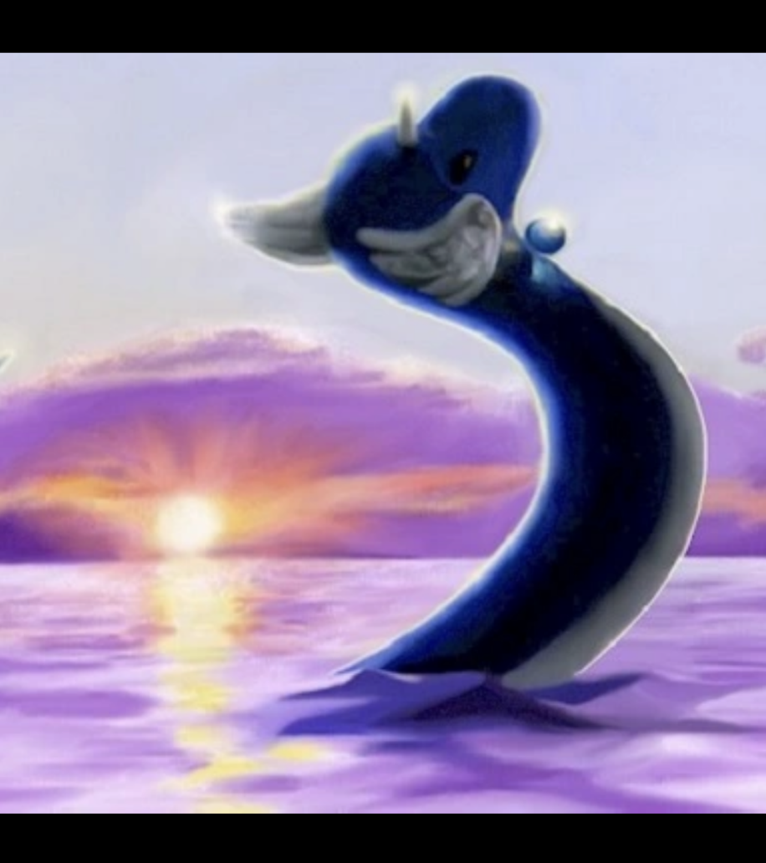

Richard: …so, uh… anyone for the spa again?

